Must Have Airbnb Gadgets
From door locks to wireless thermostats, technology is reducing the time and cost associated with short-term rental hosting. Here are the most critical gadgets to make your life easier as a rental property owner.

Door Locks
In the instance that we are unable to personally meet every guest at check-in due to same time check-ins, the alternative is to provide your guests with a means to access your property without you/us being present. You can do this using either a smart lock or a lock box.
When selecting a digital lock, you can either switch out the entire lock assembly or add hardware to your deadbolt. If you own your rental property, then replacing your current lock with a digital lock is your best option.
There are three things to keep in mind when purchasing a smart lock: ease of installation, remote access, and price.

Smart Lock
If you don’t want to change the code for each guest and remote access is not a concern, then I recommend the Schlage lock.
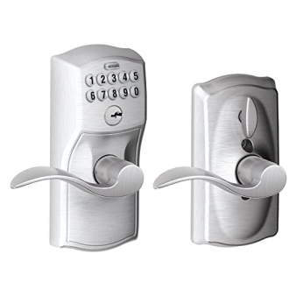
There is quite a selection; prices vary from $69 to $169.
Lock Box
Master Lock is recognised around the world as the toughest brand of padlocks and security products.
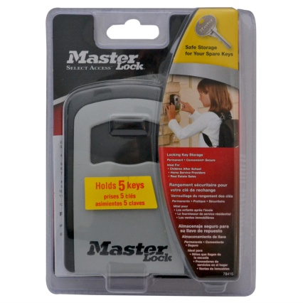
Select Access® key safes are the safest places to store and share your spare keys. Set your own combination and choose who has the combination.
- Ideal for guests, tradesmen and housekeepers.
- Wall mount design for permanent installation
- Set-your-own 4-digit combination for keyless convenience
- Holds up to 5 keys in a convenient location
- Cover protects combination dials from weather, dirt and grime

Prices vary from $40 to $50. Purchasable from Bunnings.
For maximum security and convenience, you could install digital locks on external doors and hide a lock box with a spare key elsewhere on the property.
You might want to have at least two backups so your guests aren’t stranded outside your property waiting for us/you to let them in.
Wireless Thermostats
A revolutionary new technology that helps automate property maintenance is Nest. Acquired by Google, Nest is a digital thermostat that can be remotely controlled by your iPhone.
Energy costs throughout the year can add up. Especially if you cool your place for days at a time when no one is home. Nest has a motion sensor that activates your heating or cooling when someone arrives. This can result in significant savings throughout the year.
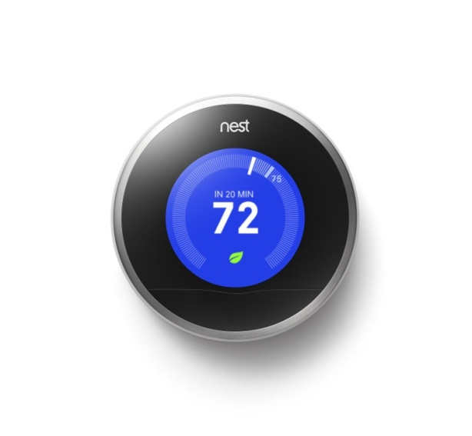

Smart TV
Airbnb guests expect high quality entertainment options. As an Airbnb host, you have an advantage over hotels. Most hotels offer outdated televisions with limited or overpriced movie options. Large LCD and LED televisions are getting cheaper every year. They are a great selling point for a short-term rental.
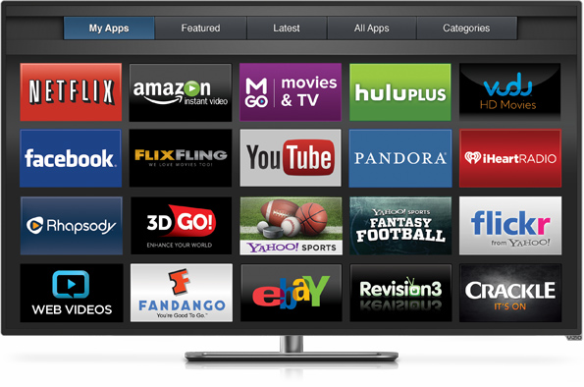
Buying a Smart TV reduces the devices in your home and help prevents the frustrating “how do I use turn this on” question. You have one remote control, one device, and one power button.
“Smart” means the TV is connected to the internet. It transforms your TV into a full service entertainment center. This includes streaming movies through Netflix, watching Foxtel, or playing music through Spotify/Pandora. The intuitive interface of a smart TV makes navigating between applications a breeze. It removes the need for guests to move in-between different component inputs and outputs and allows them to stream movies.

Cutting the Cord to Paid TV
Finding the right mix of streaming devices and antenna to replace your Foxtel system might seem like a headache. Below are simple ways to cut the cable, keep the Internet, and save yourself at least $100 per month.
There are three items you need before cancelling you cable subscription.
1. A Streaming Device – (Smart TV, Roku, Apple TV)
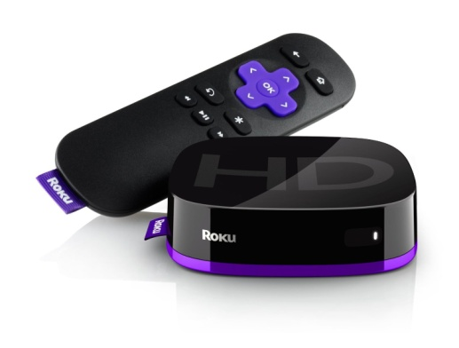
If you own a television that is not “smart,” you need to add a steaming device to your set-up. Invest the $50 in a streaming device!
We think, the best streaming device on the market today is the Roku. It's simple interface and user friendly remote provides search functionality for programs between all of your apps. It also has a headphone jack.
2. A Digital Antenna
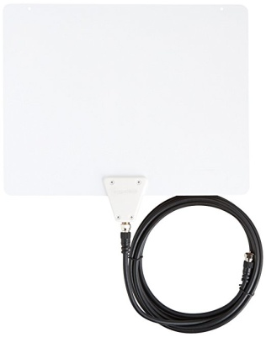
If you are within 40KM/25 miles of civilization the Amazon digital antenna offers good value. We’ve purchased different antennae and this one has outperformed all others. We recommend splurging for the most powerful version which picks up signals from up to a 80km/50 mile range. There’s nothing worse than trying to save $20, then realizing you only get 4 channels and they’re all pixelated.
Go to Antennas Direct to find out how far your home is from the local broadcasting transmitters.
3. A Streaming Content Application
Most subscription services allow you to link up to five devices. This means that you can pay for services for your home TV and also have them linked at your rental properties. Some applications are getting more restrictive about watching the same show on two different devices, but for the most part they are not cracking down on linking multiple devices to a single account.
The Best Streaming App
Netflix – Available in most countries, it’s the market leader for streaming apps.
Cutting the cord to paid TV can save you over $1,000 each year. Our research shows that less that 50% of Airbnb rentals around the world offer paid TV. This presents you with an excellent opportunity to join the digital revolution and offer your guests a superior entertainment experience!

